**Preamble to Product Market Fit …**

* Not all products are created equal is an old adage.
* Products from the biggest of companies with seemingly unlimited resources, experience & expertise sometimes turn up as dead ducks ….
* A category leader launches a brand extension only to realise the new product has no traction at all.

**But WHY?**

The singular answer to these & many other questions where products launched with lots of resources, fanfare & thought do not work is the lack of Product market fit.

**So, what’s Product Market Fit?**

PRODUCT MARKET FIT is the magical moment when consumer needs meet a product with the right features & benefits and chemistry happens between them. They fall in love & create a virtuous cycle that produces a boom in sales & profits.

**The Product Market Fit Process**

While from the outside PRODUCT MARKET FIT might look like providence & happenstance, at the heart of it lies a very engineered & rigorous process.

We at “Strategii At Work” have designed a 5C Fit model that looks at business propositions from 5 Critical lenses & enables PRODUCT MARKET FIT.

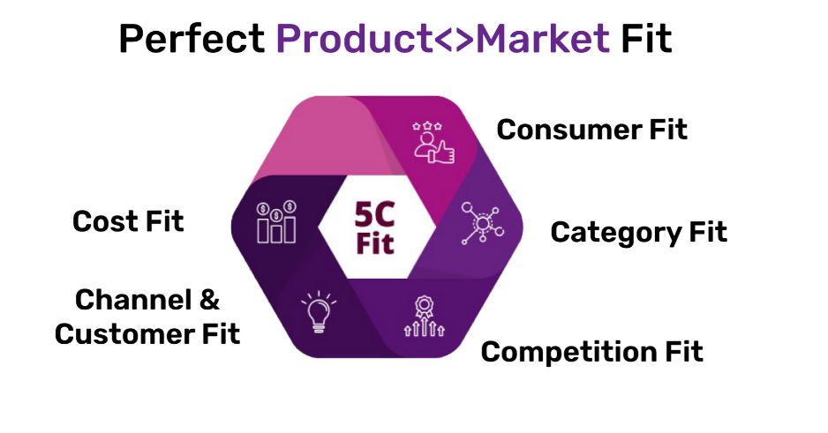

**1—PRODUCT MARKET FIT Consumer Fit** – At the heart of any business lies the consumer. The consumer who will ultimately vote with their wallet for our product Vs other available options from competition. A deep, clear understanding & articulation of the consumer “WHO” is the 1st perhaps the most critical step to achieving PRODUCT MARKET FIT.

**2—PRODUCT MARKET FIT - Category Fit -** If a product is trying to build a totally new category, then the challenges usually tend to be large with the product having to answer two layers of questions (i) “why do I need this category” (ii) “why do I need this brand”.

Quick commerce is a great example where, for 99% of the population, the question of “why do I need grocery to be delivered in 10 minutes” remains unanswered. Only after this deselection barrier is broken does the question of do I choose brand A, B or C even arise.

When new products enter an existing category the additional dimension of competition fit comes into play.

**3—PRODUCT MARKET FIT - Competition Fit:** A new product in an existing category means talking to consumers who already have their needs fulfilled by existing products & players. In this case the product story takes on of two possible directions:

(1) Be a NEW mouse trap – a new solution, a new way of defining the consumer problem & hence a new solution. Spotify, Netflix, Slack etc are great examples of changing the existing category paradigm & moving categories to a new way of product<>consumer interaction.

(2) Be a BETTER mouse trap – an innovation on the existing to deliver results that are faster, better, cheaper or some combination of these. Android is a great example of this. Android in many parts of the world leads Apple by far & its core proposition builds around flexibility, more choices, more dispersed innovation & hence lower prices Vs Apple.

**4—PRODUCT MARKET FIT - Channel & Customer Fit**

While brands & products have many ways to reach their consumer, the choice of the right channel & customers can be a make-or-break decision.

Cost To Serve: Channels & customers usually end up defining what’s called the “cost to serve” i.e. the cost that the brand incurs to reach products to consumers. Needless to state that the least cost channels & customers will be crowded & clutters & the most expensive will not make economic sense for brands & products.

Reach to TAM: On the other hand, this decision also needs to be weighed from a reach to TAM perspective. TAM is the total addressable market or the total number / value of consumers that the product desires to reach. Not all channels will be able to provide access to the same TAM. So, the choice to be made here is prioritizing the right TAM VS channel combination.

**5—PRODUCT MARKET FIT - Cost Fit**

Ultimately everything must be worked back from the point of “consumer willingness to pay” & the long-term profit expectation. This decision point filters into every product decision from features & benefits to communication, channel, customer & other choices.

**PRODUCT MARKET FIT – Art & Science**

The 5c model thus creates a compelling framework that leads to PRODUCT MARKET FIT. Even with the robust 5C framework there are two sides to getting the PRODUCT MARKET FIT right:

* The science that leverages the 5C framework & takes the product through the 5 lenses & helps arrive at PRODUCT MARKET FIT.
* The Art: a delicately orchestrated mix of multiple vectors that are likely to create the optimal proposition for the consumer & viable scalability for the product, leading to long term profitable growth through PRODUCT MARKET FIT.

**PRODUCT MARKET FIT indicators**

While there are many indicators & measure of PRODUCT MARKET FIT, we like the ones noted below for (i)ease of finding data, (ii)ease of being objective with use of hard Vs soft data & (iii) ease of measuring over long trend periods.

1. 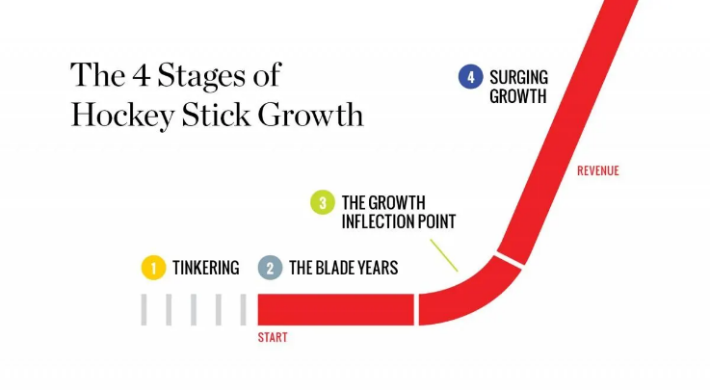**The hockey stick phenomenon:** A sudden surging unmistakable uptick in sales will happen.
2. **Positive CAC < > LTV” equation**

* CAC – Customer acquisition cost. Total costs a product incurs to generate one consumer.
* LTV – Lifetime value. The long-term sales potential of one consumer
* Positive CAC<> LTV ratio … LTV becomes larger than CAC.
* Example: ||CAC $50 || LTV $300 || Ratio = 300/50 = 6||Typically ration >3 is considered good, & >5 considered stable indicator of PRODUCT MARKET FIT.

1. **Positive CRR equation**

* CRR – Customer retention ratio = Net customers (total – new) at the end of a period /customers at the start of the period.
* Depending on the length pf period 50-60% CRR typically indicates achievement of PRODUCT MARKET FIT.

We love helping our customers find PRODUCT MARKET FIT with new products, categories, countries, channels & more. For more information & case studies visit us at <https://www.strategii.works/>

**-- ##%%&&%%##--**